Project Proposal

ME 195A, Spring 2025

Smart Refrigerator

Faculty Advisor: Dr. Keith Yi, keith.yi@sjsu.edu
Technical Advisor: Dr. Kabbani, hussameddine.kabbani@sjsu.edu

Student Team Members (name, phone#, email)
1. | Isabel Price (team lead) | (669) 333-1464 | isabel.price@sjsu.edu
2. | Brent Marin | (650) 293-1821 | brent.marin@sjsu.edu
3. | Caleb Mok | (408)-309-3238 | caleb.mok@sjsu.edu
4. | Kalino Ruiz | (669) 333-1462 | kalino.ruiz@sjsu.edu
5. | Matthew Manuel | (408)-316-1427 | matthew.manuel@sjsu.edu

Student Team:
Isabel Price |  |  | 3/18/2025
Brent Marin |  |  | 3/18/2025
Caleb Mok |  |  | 3/18/2025
Kalino Ruiz |  |  | 3/18/2025
Matthew Manuel |  |  | 3/18/2025

- Introduction
With the knowledge we now have about various environmental problems centered around climate change, it is our duty to create a sustainable world and minimize our carbon footprint. One way we can do this is by reducing the average household energy expenses with the help of energy efficient appliances. By leveraging active and passive refrigerating techniques, we can incorporate a local ice storage system into a refrigerator that will generate ice during off peak hours which will maintain the internal temperature of the fridge during hours of peak electricity rates. Utility rates are how much we are charged for energy. When utility rates are higher during peak hours, we aim to use the passive cooling method to save the user money. The smart refrigerator intends to provide users with an eco-friendly and affordable option by decreasing utility rates and energy consumption.

- Project Objectives
Our primary objectives include:
- Make an affordable, energy-efficient, and cost saving refrigerator
- The refrigerator must have easy to clean removable shelves
- A microcontroller will control the state of the refrigeration cycle

We want to build or repurpose a mini refrigerator that has an active and passive cooling cycle. The passive cycle relies on the principle of stored thermal mass to limit consuming energy during peak-load hours to save the consumer money. As a group we decided that our project will not be a success unless both active and passive cooling cycles work effectively. Lastly we want to retain as much of the original insulation in our mini refrigerator.

- Customer Requirements
As a group we conducted a survey to get feedback on what people are looking for regarding refrigerators. We had 22 responses, with ages from 18 to 55+, about 54% of our responses were women and the rest were men. Once we received our input, as a team, each group member weighed each need on their own. The three highest customer needs for a refrigerator were: interior storage space, durability, and that it is easy to clean. Within our team, the three highest needs were interior storage space, the cost of the product, and the energy usage. The full customer needs results can be found below in Appendix B.

- Background Research
Though there are not any currently commercially available refrigerators with integrated passive cooling methods, there have been studies conducted on refrigerator prototypes, refrigerated transport boxes, and air conditioning systems that use various methods of passive cooling. Garber-Slaght of the Cold Climate Housing Research Center conducted an experiment comparing regular refrigerators to a prototype unit with thermal fins located outside of the building, exposed to the winter conditions (2013). The results showed that the retrofit prototype unit used 6.3 kWh compared to 36.1 kWh for the regular units during the winter, though it underperformed during the summer due to the fins absorbing additional heat rather than cooling. This shows that passive refrigerator models can be effective in saving consumers money.

Other technologies and prototypes exist that use thermal mass as a means of either maintaining refrigerated temperatures for durations of time. Fauer and Cremaschi developed a transport box for blood bags that successfully maintained the temperature between 2 and 6 ℃ for an extended period of time using only phase change materials as a form of thermal mass (2024). Our Smart Refrigerator will be a combination of these technologies as it will integrate the thermal mass method of refrigeration boxes into the typical form of a refrigerator with a refrigerant loop and compressor.

- Design Constraints
There are four main constraints regarding our project. They are: budget limitations, material availability, safe operation, and sound levels produced. Funding is limited from our sponsors and the members of this group have a limit they are willing to spend individually. Regarding the construction of the insulation of our project, some materials are far better at insulating heat than others, but are not always readily available for sale to the public nor cheap. When it comes to prototyping our project, consumer safety is our number one priority so we will be avoiding flammable refrigerants.Our last constraint is sound level, this mainly pertains to the compressor. While it may be more cost and power efficient to go with a cheap, large, or low quality compressor, we want to design a product that consumers will use and not notice.

- Project Plan & Gantt Chart

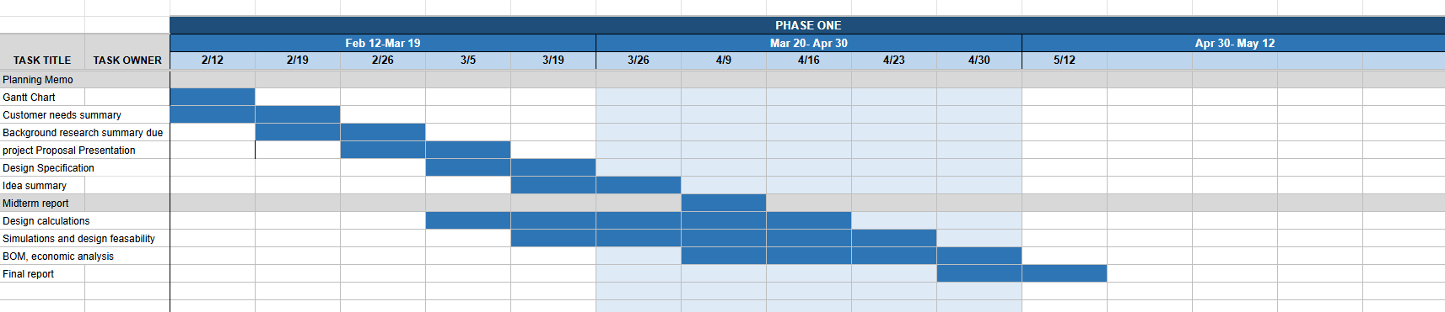

We aim to work as a team toward the final report for the semester. Our work is currently split between technical leads who will be in charge of CAD, heat transfer calculations, fabrication, code, the refrigeration cycle, and mechatronics/sensing. We still plan to have all team members help each other on their lead assignments. Strong communication is a cornerstone of all work to be done. Our general strategy is to work ahead of time on as many assignments as is reasonably possible, which is why we have already started rough design calculations and economic analysis, as both go hand-in-hand with testing the viability of our project.

References

Fauer, C., & Cremaschi, L. (2024). Passive cooling of two phase change materials installed in series. International Journal of Refrigeration, 159, 124–133. https://doi.org/10.1016/j.ijrefrig.2023.12.024

Garber-Slaght, R. (2013, March). Passive Refrigeration. Cold Climate Housing Research Center; CCHRC. https://cchrc.org/wp-content/uploads/media/passiverefrigeration.pdf

Appendices
- Mission Statement
- Customer Needs Summary
- Teamwork Plan



